Effect of dietary supplementation of phytogenic feed additives on broiler performance and economic efficiency

Department of Nutrition and Clinical Nutrition, Faculty of Veterinary Medicine, Benha University

Authors : Nasser E. Khedr , Tahia E. Ahmed , Aya Mahmud Ahmed

Abstract
This study was conducted to explore the use of phytogenic feed additives (PFAs) in broiler nutrition as a natural growth promoter. Two commercial phytogenic products; Activo ® and Digestarom® P.E.P were added to a standard diet to determine their effect on growth performance and cost economics. A total of 180 one-day-old chicks (Cobb 500) were allotted to three treatment groups of three replicates (20 chicks / replicate). The dietary treatments were as follows: group (1) control (basal diet), group (2) basal diet + 100g/ton Activo® and group (3) basal diet + 150g/ton Digestarom® . Results showed that chicks fed PFAs had significantly higher (P ≤ 0.05) body weight and body weight gain than control, however feed intake was decreased (P ≤ 0.05) in supplemented groups than control and, in turn, caused an improvement (P ≤ 0.05) in feed conversion ratio. European Broiler index was increased in Activo® fed group and Digestarom® fed group compared to negative control. Interestingly, a lower feed cost was recorded in the supplemented groups combined with a higher growth rate and, therefore, a higher net return was observed. Moreover, economic efficiency showed a significant (P ≤ 0.05) difference in PFAs supplemented groups compared to the control .In conclusion, supplementation of broiler diets with PFAs can improve body weight gain, feed conversion ratio and overall broiler performance .The best economic efficiency was recorded in broilers fed PFAs.

Key words: Phytogenic feed additives , Broiler, Growth performance, Cost economics
1. Introduction
In the past, antibiotic growth promoters (AGPs) have been widely used to achieve improvement in animal performance. However, because antibiotic resistance became a serious problem, many countries have completely banned or limited their use (Saeed et al., 2020). Several natural growth promoter (NGPs) such as plant extracts (Phytobiotics), probiotics, prebiotics, symbiotic and organic acids etc., have been recognized as an efficient and safe alternatives that can promote animal health and productivity (Makkar et al., 2007) . Phytogenic feed additives (PFAs), also known as Phytobiotics or NGPs, are plant extracts obtained from herbs or spices, that increase animal productivity and efficiency by stimulating digestion and improving the utilization of digestive products through improved liver functions (Ding et al., 2017), antimicrobial and antioxidant properties (Placha et al., 2010) . Herbs, spices, and their extracted oils are incorporated in poultry nutrition to increase the efficient use of nutrients resulting in faster body weight gain, greater production rates, and increased feed quality, both of which improve overall animal efficiency (Abdel-Wareth et al., 2012). Positive results were observed on the body weight and body weight gain of chicken supplemented with 300 mg/kg of a mixture containing capsaicin, cinnamaldehyde, and carvacrol (Jamroz and Kamel, 2002). Also, addition of 20% Activo to broiler diets significantly improve feed conversion ratio compared to control diet (Samarakoon et al., 2019) ,these improvement may resulting in higher economic efficiency in broiler meat production (Amad et al., 2011). Dietary supplementation of Phytobiotics to broiler diets may be useful for increasing gross return thus improving economic efficiency and increasing profitability (Singh et al., 2018). So that, the objective of the current study was to determine the effects of phytogenic feed additives in broiler ration as a natural growth promoter on growth performance and cost economics .
2. Materials and Methods
2.1. Test substances
Two commercial phytogenic products were used in this study ,
- Activo ® : a blend of essential oil extracted from herbs and spices that containing Carvacrol ,Thymol, Cineol, Cinnamaldehyde, Capsaicin as active component. according to ( EW Nutrition GmbH , Germany)

- Digestarom® P.E.P is a mixture of natural herbs enriched with special extracts and essential oils , contained active components : Carvacrol , limonene, Anethol and Fructo-oligoscaride
according to (BIOMIN GmbH , Austria)

The PFAs used in this study was included in diet according to the manufacturer's recommendation.
2.2. Birds, diets, and management of broilers
The present study was performed at the Nutrition and clinical Nutrition Department, Faculty of Veterinary Medicine, Benha University in accordance with guidelines of Institutional Animals Care and Use Committee Research Ethics Board (No BUFVTM 03-01- 21)
A 35-day experiment was conducted with 180 one-day-old Cobb 500 broilers with average weight (42.90g) . The broilers were weighed at day 1 and randomly distributed into 3 treatment groups consisting of 3 replicates with 20 birds per replicate. The corn-soybean meal-based diets were formulated as recommended by NRC (1994) for broilers and all the diets were similar in nutrient composition as shown in Table (1).
The dietary treatments were as follows: group (1) basal diet (control), group (2) basal diet + 100g/ton Activo®, group (3) basal diet +150g/ton Digestarom® P.E.P . All chicks were vaccinated for NDV on day 7, 10 and IBD on day 14. Mash feed and water were provided ad libitum.
The experimental house was properly cleaned and disinfected before start of the experiment. The chickens were housed in floor pens (2 × 1.3 × 0.5 m²) on fresh ,clean saw dust litter. Proper ventilation was maintained, and birds received a lighting regimen of 23hr Light :1hr Dark to minimize the chickens' activity. The temperature was set at 35°C for the first week, then gradually decreased by 3°C per week and finally maintained at 24°C.
Table (1): Physical and chemical composition (%) of the starter ,grower and finisher diets
Diet formulations
 | Starter ration  day(0-10) |  | Grower ration  day(11-24) | Finisher ration  day(25-35)
Ingredients | (%) | (%) |  | (%)
Yellow corn | 57.595 | 62.060 |  | 66.245
Soybean meal (46) | 35.00 | 31.700 |  | 27.300
Corn gluten meal | 1.700 | 0.500 |  | 0
Limestone | 1.665 | 1.550 |  | 1.450
Mono calcium phosphate | 1.200 | 1.030 |  | 0.900
Soyabean oil | 0.950 | 1.500 |  | 2.400
DL -Methionine | 0.330 | 0.270 |  | 0.300
Lysine Hydrochloride | 0.30 | 0.220 |  | 0.240
Vit. &Min. Mixture¹ | 0.300 | 0.300 |  | 0.300
Sodium bicarbonate | 0.275 | 0.200 |  | 0.220
Sodium chloride | 0.230 | 0.250 |  | 0.250
L -Threonine | 0.130 | 0.100 |  | 0.080
Aleta² | 0.100 | 0.100 |  | 0.100
Choline chloride | 0.100 | 0.095 |  | 0.090
Anti-mycotoxin | 0.50 | 0.050 |  | 0.050
Nutrikem Extend³ | 0.50 | 0.050 |  | 0.050
Phytase H.T 85 enzyme⁴ | 0.010 | 0.010 |  | 0.010
Lincomix | 0.010 | 0.010 |  | 0.010
Xtrapro⁵ | 0.005 | 0.005 |  | 0.005
Analyzed value
ME ( Kcal \ Kg diet ) | 3,034.670 | 3,102.840 |  | 3,198.710
CP % | 23.010 | 21.000 |  | 19.020
CF% | 2.290 | 1.950 |  | 2.340
Crude fat% | 3.510 | 4.120 |  | 5.090
Lysine | 1.350 | 1.200 |  | 1.100
Lysine dig | 1.230 | 1.090 |  | 1.000
Methionine | 0.660 | 0.570 |  | 0.580
Methionine dig | 0.630 | 0.550 |  | 0.550
Methionine + cysteine | 1.020 | 0.900 |  | 0.880
Methionine + cysteine dig | 0.920 | 0.820 |  | 0.800
Threonine | 0.950 | 0.850 |  | 0.750
Threonine dig | 0.830 | 0.740 |  | 0.660
Calcium | 0.960 | 0.880 |  | 0.800
Available phosphorus | 0.490 | 0.440 |  | 0.400
Chloride | 0.230 | 0.230 |  | 0.230
Sodium | 0.170 | 0.160 |  | 0.160
Potassium | 0.880 | 0.820 |  | 0.740

Formulations are representative of basal diets, when applicable (Activo) ® ,was incorporated (100g/ton ) at the Top of diet , when applicable( Digestarom)®, was incorporated (150g/ton ) at the Top of diet.
Vitamin-mineral mixture¹ was composed of:
Each 2 kg contain:
Vit. A 12000000 IU, vit. D₃ 3500000 IU, vit. E 30000 mg, vit. K₃ 3000 mg, vit B₁1000 mg, vit. B₂ 5000 mg, vit B₆ 2500 mg, vit. B₁₂ 20 mg, Biotin 100 mg, pantothenic acid 10000 mg, Niacin 35000 mg, Folic acid 1000 mg, Manganese 620000 mg, Zinc 75000 mg, Iron 440000 mg, Copper 50000 mg, Iodine 1300 mg, Selenium 226 mg, Cobalt 100 mg, carrier (CaCo₃) up to 2 kg. Ethoxyquin 1300mg,
Vitamin-mineral mixture produced by AGRI-VET 10th of Ramadan city A2, Egypt.
Aleta ² : immunostimulant produced by kemin company (Belgium).
Nutrikem Extend ³ : energy releasing enzymes produced by kemin company (Belgium).
Phytase⁴ : ( Avemix P5000 ) was used as feed additive for poultry at a rate of 0.10 g/Kg.
Xtrapro⁵ : protease enzyme produced by Genencor international oy (Finland).
2.3 . Growth performance parameters
Body weight (BW) of all chickens was measured on day 1, then at weekly intervals, and body weight gain was calculated replicate-wise. Weekly feed intake was determined by subtracting the amount of feed remained from the total amount of offered food in each pen.
2.4. Economical evaluation: -
Economic efficiency measures calculated as the following: -
- Total cost per chick = Total feed cost + Management of chick (L.E) + chick price (at the start of experiment, L.E).
- Total revenue per chick (L.E) = final body weight (kg) * selling price of kg chick live body weight offered in the market (L.E).
- Net revenue per chick (L.E) = Total revenue per chick - total cost per chick (L.E).
- Economic efficiency = net revenue per chick/total cost per chick (L.E.).
- Relative economic efficiency = Economic efficiency of each experiment group/ economic efficiency of the control group *100
2.5. Statistical analysis
All values were expressed as mean ± SEM. Mean values were compared among treatment groups using ONE- WAY ANOVA and subsequent Duncan’s multiple range test (Duncan, SPSS Student Version 10.0.7, June 2000) was performed. Differences among means at the level of (P<0.05) were considered statistically significant.
- Results

Table (2): Effects of feeding (Activo) ® , (Digestarom)® P.E.P on broiler performance
(means ± SE)

Items | Groups
 | Group fed Control diet | Group fed diet containing  (Activo) ® | Group fed diet containing Digestarom)®)
Initial weight (g) | 42.44 ª ± 0.20 | 41.74 ^{b} ± 0.26 | 41.45 ^{b} ± 0.26
Final weight (g) | 2003.79 ^{b} ± 34.40 | 2112.12 ª ± 28.26 | 2007.70 ^{b} ± 36.23
Body weight gain(g) | 1973.06 ^{b} ± 32.88 | 2070.25 ª ± 28.25 | 1982.15 ^{ab} ± 37.44
Daily Body weight gain(g) | 56.37 ±0.93 | 59.15 ± 0.80 | 56.67 ± 1.09
Feed intake  (g ) | 3023.85 ª ± 2.42 | 2932.10 ^{b} ± 4.67 | 2858.99 ^{c} ± 13.09
Daily Feed intake  (g ) | 86.39 ª ± 0.06 | 83.77 ^{b}± 0.13 | 81.68 ^{c} ± 0.37
Feed conversion  rate | 1.54 ª ± 0.010 | 1.46 ^{b} ± 0.015 | 1.44 ^{b} ± 0.021
European broiler index | 351.24 ^{b} ± 12.22 | 404.44 ª ± 9.67 | 383.69 ^{ab} ± 9.26

Values are means ± standard errors.
Means with different letters at the same raw differ significantly at (P≤0.05)

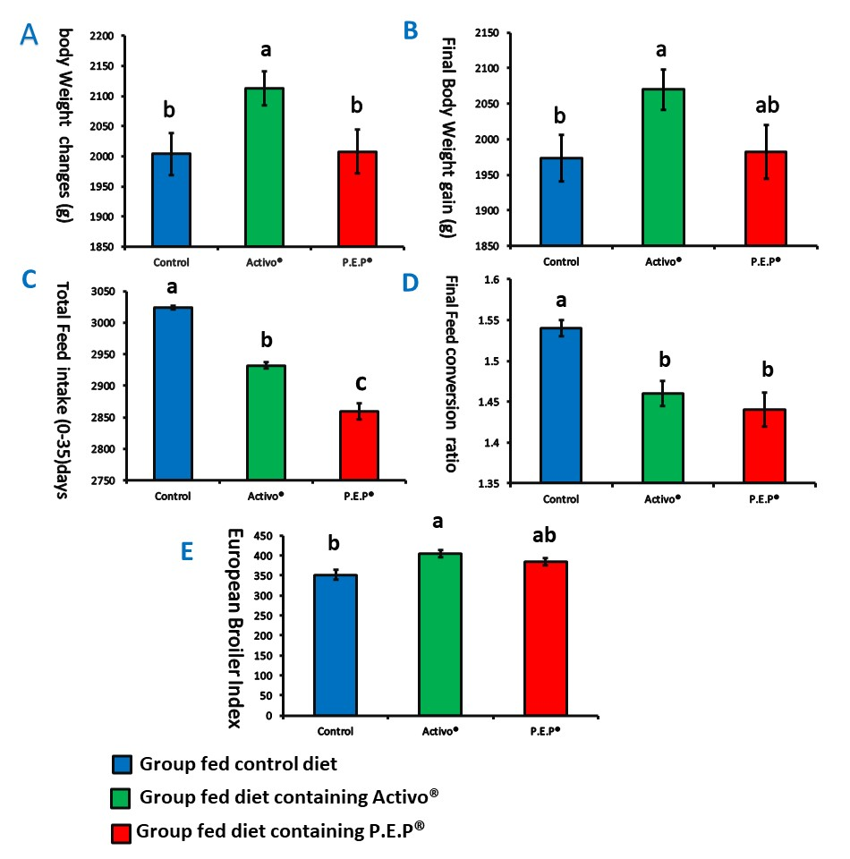

fig (4): Effects of feeding (Activo) ® , (Digestarom)® P.E.P on broiler performance

Table (3): The effect of feeding (Activo) ® , (Digestarom)® P.E.P on economic efficiency
(means ± SE)

Items | Groups
 | Group fed Control diet | Group fed  Diet containing  (Activo) ® | Group fed  Diet containing  ( Digestarom)®
Number of chicks | 60 | 60 | 60
Price per chick (L.E) | 6 | 6 | 6
Final body weight (g) | 2003.79 ^{b} ± 34.40 | 2112.12 ª ± 28.26 | 2007.70 ^{b} ± 36.23
Average daily feed intake (g) | 86.39 ª ± 0.06 | 83.77 ^{b} ± 0.13 | 81.68 ^{c} ± 0.37
Vaccination (L.E) | 1.11 | 1.11 | 1.11
Drugs (L.E) | 0.83 | 0.83 | 0.83
Total feed cost  (L.E) /chick | 18.47 ª ± 0.09 | 17.91 ^{b} ± 0.13 | 17.53 ^{b}± 0.22
Total cost  (L.E) | 29.52 ª ± 0.09 | 28.95 ^{b} ± 0.13 | 28.57 ^{b}± 0.22
Selling price(L.E) | 24 | 24 | 24
Total return/  chick | 49.76 ^{b}± 0.16 | 52.33 ª ± 0.81 | 49.77 ^{b} ± 0.22
Net revenue  /chick | 20.24 ^{b}± 0.24 | 23.38 ª ±0.68 | 21.19 ^{b}± 0.27
Economic efficiency | 0.68 ^{c}± 0.01 | 0.80 ª ± 0.02 | 0.74 ^{b}± 0.01
relative Economic efficiency % | 100.00 ^{c}± 00.00 | 117.74 ª ± 2.93 | 108.18 ^{b}± 2.03

Values are means ± standard errors.
Means with different letters at the same raw differ significantly at (P≤0.05)

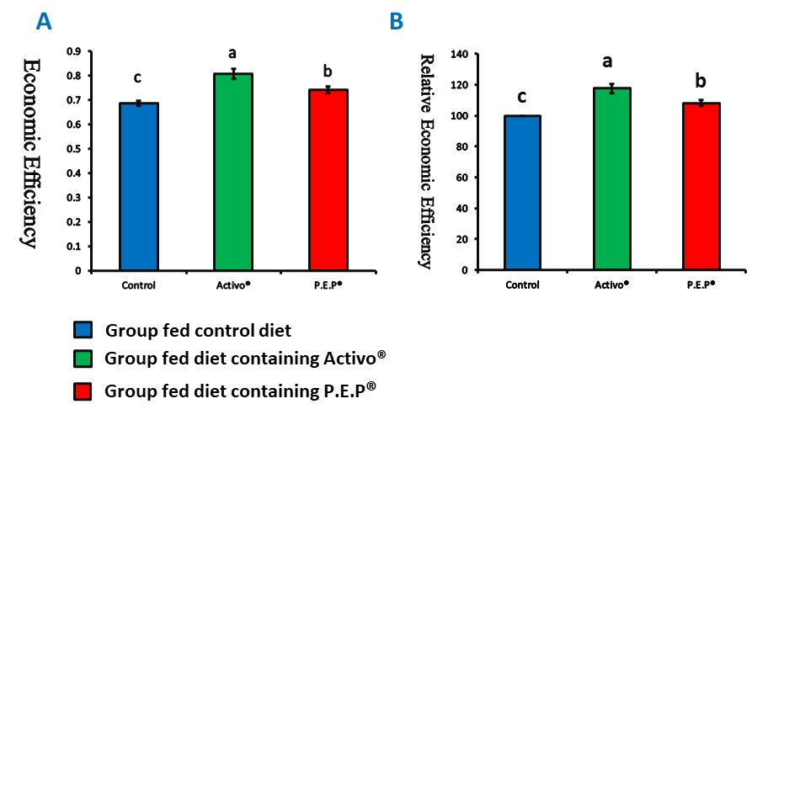

fig (2): The effect of feeding (Activo) ®, (Digestarom)® P.E.P on economic efficiency

Growth performance

The effects of dietary supplementation of PFAs on growth performance of broiler chickens are summarized in Table (2). The results obtained indicated that adding PFAs to broiler diets significantly (P ≤ 0.05) increase final body weight and body weight gain , birds receiving diet containing Activo® showed an improvement in performance (2070.25 g BWG) ,followed by group supplemented with Digestarom® (1982.15 g BWG) and the control group showed the lowest final body weight gain (1973.06 g BWG) as shown in figure (1A,B) .
Regarding feed intake, the data analysis revealed that there was a significant (P ≤ 0.05) decrease in total feed intake of the PFAs supplemented groups than control group and Digestarom® fed group show the lowest value , as recorded in figure (1C) . In addition, the final feed conversion ratio showed a significant (P ≤ 0.05) improvement in PFAs supplemented group in relation to control figure (1D) . European Broiler index was affected by dietary supplementation of PFAs and significantly (P ≤ 0.05) increased compared to control group , The Activo ® fed group recorded the highest value (404,44) followed by Digestarom® fed group (383.69) and the control group recorded the lowest value (351.24 ) figure (1E).
Economic efficiency

(Table 3) shows results of the economics of cost , return and economic efficiency in relation to the dietary supplementation of PFAs in the broiler diets. Total feed cost showed significant (P ≤ 0.05) decrease in PFAs supplemented groups , group supplemented with Digestarom® shows the lowest cost (17.53) L.E , followed by activo® supplemented group (17.91) L.E compared to control group (18.47)L.E .The net economic return revealed significant (P ≤ 0.05) higher profit in the birds fed PFAs, group (2) supplemented with Activo® shows the highest value between the groups (23.38) L.E . Moreover, there was a significant (P ≤ 0.05) increase in economic efficiency in supplemented groups as shown in figure (2A) ,and the highest value was recorded in activo® supplemented group (0.80) , followed by (0.74) in Digestarom® group and the control group shows the lowest value (0.68) . Also, there was a significant (P ≤ 0.05) increase in relative economic efficiency in supplemented groups compared to control ,and the highest value was observed in activo® supplemented group (117.7%) figure (2B).

4-Disscusion
The obtained results revealed that supplementation of PFAs significantly (P ≤ 0.05) improved live body weight at five weeks of age and final body weight gain when compared with control. This result agree with that of This results are in line with that of Samarakoon et al., (2019) who investigate the effect of adding Activo 20% to the broiler diets and found that body weights and body gain of birds supplemented with 20% Activo were significantly higher (P<0.05) compared to the broilers fed with control diet. Also , Hafeez et al., (2016) who reported that the inclusion of (150mg/kg) anethole or (100mg/kg) thymol, and carvacrol as dietary supplements improves the final body weight of birds and overall body gain from day one to day 42. In addition , Skoufos et al., (2016) suggested that the improvement in performance of broiler supplemented with phytobiotics may be related with increasing the intestinal villus height and limiting the intestinal pathogens thus result in increasing surface area of absorption and improving nutrient digestion and absorption .
Feed intake was decreased in supplemented groups than control and, in turn, caused an improvement (P ≤ 0.05) in feed conversion ratio. Our results were supported by Zhang et al., (2005) who studied the effect of adding 150 g /ton of (oregano, cinnamon, thyme and capsicum) and reported reduced feed intake in relation to control group . Also, Cross et al., (2007) noted a reduction in feed intake of broiler receiving diets contained 10g oregano/kg , thus proposing that young chicks might be sensitive to taste and odor characteristics. Similarly , Glamoclija et al., (2016) , found that dietary supplementation of Phytobiotics decreased the overall feed consumption compared to control group , one possible reason is that the essential oils have an irritating smell, that making palatability of the diet unpleasant to birds .In addition, Cho et al., (2014) concluded that supplementing broiler diets with 250 mg/kg anise and thyme as a feed additives resulted in a significant improvement in feed conversion ratio. Furthermore, Hashemi et al.,(2014) explained the improvement in feed conversion ratio of broiler that could be closely associated to improvement in gut health and intestinal morphology in chicks supplemented with Phytobiotics .

European Broiler index was affected by dietary supplementation of PFAs and significantly (P ≤ 0.05) increased compared to control group . These results may be because of increasing viability, increasing final body weight, and improving feed conversion ratio in the supplemented groups . This results agreed with El-Ashram and Abdelhafez, (2020) who studied the effect of 300 mg/kg mixture of thyme and star anise on broiler chicks and found that the highest value of the European Broiler index was recorded in supplemented groups compared to the control. Also , Arczewska -Wlosek and Swiatkiewicz, (2012) who found that addition of a blend of essential oils containing thyme and oregano to broiler diets result in improvement in European Broiler index of supplemented groups in relation to control . In addition , Al-Kassie et al., (2011) revealed that the supplementation of hot red pepper at levels 0.50%, 0.75% and 1% to chicken dietary mixtures result in significant increase in European Broiler index compared to control group .

In Relation to economic efficiency in this study ,supplementing broiler diet with PFAs showed a reduction in total cost and significantly improved economic and relative economic efficiency.
These result are in agreement with , Singh et al., (2018) who concluded that the feed cost per kg body gain was significantly (P<0.05) lower in group supplemented with 1.5 , 2 % phytogenic product compared to control group. They also found that Economic efficiency index (EEI) was highest in group supplemented with (2.0 % phytobiotics) compared with other groups. Also , Oleforuh-Okoleh et al., (2014) who recorded that highest revenue and net return was obtained from birds fed on herbal supplemented diet that may be attributed to the better efficiency of feed utilization, which resulted in more growth and better feed conversion ratio . Also , EL-Faham et al ., (2014) reported that using (500 g/ton) of natural feed additives in broiler diets record the highest economic and relative economic efficiency being 31.81 and 134%, respectively (this may be due to improvement in broiler performance (live body weight ,body weight gain and feed conversion ratio) and meat yield that led to increase in total return and economic efficiency.

5- Conclusion
In conclusion, Phytogenic feed additives can be used as a natural growth promoter to improve final body weight ,body weight gain and final feed conversion of broiler chicks, and 100g/ton Activo® tended to be more effective. These effects can result in higher economic efficiency in broiler meat production.

6- References

Abdel-Wareth, A. A.A., Kehraus, S., Hippenstiel, F., and Südekum, K. H. 2012. Effects of thyme and oregano on growth performance of broilers from 4 to 42 days of age and on microbial counts in crop, small intestine and caecum of 42-day-old broilers. Animal Feed Science and Technology, 178(3–4), 198–202.
Al-Kassie, G. A. M., Al-Nasrawi, M. A. M., and Ajeena, S. J. 2011. Use of black pepper (Piper nigrum) as feed additive in broilers diet. Research Opinions in Animal and Veterinary Sciences, 1(3), 169–173.
Amad, A. A., Männer, K., Wendler, K. R., Neumann, K., and Zentek, J. 2011. Effects of a phytogenic feed additive on growth performance and ileal nutrient digestibility in broiler chickens. Poultry Science, 90(12), 2811–2816.
Arczewska-Wlosek, A., and Swiatkiewicz, S. 2012. The effect of a dietary herbal extract blend on the performance of broilers challenged with Eimeria oocysts. Journal of Animal and Feed Science , 21(1), 133–142.
Brenes, A., and Roura, E. 2010 . Essential oils in poultry nutrition: Main effects and modes of action. Animal Feed Science and Technology, 158(1–2), 1–14.
Cho, J. H., Kim, H. J., and Kim, I. H. 2014. Effects of phytogenic feed additive on growth performance, digestibility, blood metabolites, intestinal microbiota, meat color and relative organ weight after oral challenge with Clostridium perfringens in broilers. Livestock Science, 160, 82–88.
Cross, D. E., McDevitt, R. M., Hillman, K., and Acamovic, T. 2007. The effect of herbs and their associated essential oils on performance, dietary digestibility and gut microflora in chickens from 7 to 28 days of age. British Poultry Science, 48(4), 496–506.
Ding, X., Yu, Y., Su, Z., and Zhang, K. 2017. Effects of essential oils on performance, egg quality, nutrient digestibility and yolk fatty acid profile in laying hens. Animal Nutrition, 3(2), 127–131.
Duncan, (SPSS program Version 10.0.7, June). 2000. ANOVA, (Analysis of variance), LSD (Least Significant Difference) and multiple range tests. Res., 28: 65-74. Biometrics, 11: 142.
El-Ashram, S., and Abdelhafez, G. A. 2020. Effects of phytogenic supplementation on productive performance of broiler chickens. Journal of Applied Poultry Research, 29(4), 852–862.
EL-Faham ,A.I., Ali, N.G. and El-Maty, H. M. 2014 . Effect of using some natural commercial feed additives to substitute antibiotic growth promoters on performance and blood parameters of broilers. Egyptian Poultry Science, 5623(34), 735–750.

Glamoclija, N., Sevic, K., Baltic, B., Boskovic, M., Janjic, J., Djordjevic, V., and Markovic, R. 2016. Effects of phytobiotics on Cobb broiler production results , meatiness and chemical composition. Meat Technology, 57(2), 89–94.
Hafeez, A., Männer, K., Schieder, C., and Zentek, J. 2016. Effect of supplementation of phytogenic feed additives (powdered vs. encapsulated) on performance and nutrient digestibility in broiler chickens. Poultry Science, 95(3), 622–629.
Hashemi, S. R., Zulkifli, I., Davoodi, H., Hair Bejo, M., and Loh, T. C. 2014. Intestinal histomorphology changes and serum biochemistry responses of broiler chickens fed herbal plant (euphorbia hirta) and mix of acidifier. Iranian Journal of Applied Animal Science, 4(1), 95–103.
Jamroz, D., and Kamel, C. 2002. Plant extracts enhance broiler performance. In non-ruminant nutrition: Antimicrobial agents and plant extracts on immunity, health and performance . Journal of Animal Science 80(1) ,41-46.
Kirkpinar, F., Ünlü, H. B., and Özdemir, G. 2011. Effects of oregano and garlic essential oils on performance, carcase, organ and blood characteristics and intestinal microflora of broilers. Livestock Science, 137(1–3), 219–225.
Makkar, H. P. S., Francis, G., and Becker, K. 2007. Bioactivity of phytochemicals in some lesser-known plants and their effects and potential applications in livestock and aquaculture production systems. Animal, 1(9), 1371–1391.
NRC 1994: National Reasrech Council .Nutrient requirement for poultry .Ninth Revised Ed.National Acadmy.USA .
Oleforuh-Okoleh, V. U., Chukwu, G. C., and Adeolu, A. I. 2014. Effect of ground ginger and garlic on the growth performance, carcass quality and economics of production of broiler chickens. Global Journal of Bioscience and Biotechnology, 3(3), 225–229.
Placha, I., Simonova, M. P., Cobanova, K., Laukova, A., and Faix, S. 2010. Effect of Enterococcus faecium AL41 and Thymus vulgaris essential oil on small intestine integrity and antioxidative status of laying hens. Research in Veterinary Science, 89(2), 257–261.
Saeed, M., Naveed, M., Leskovec, J., Ali kamboh, A., Kakar, I., Ullah, K., Ahmad, F., Sharif, M., Javaid, A., Rauf, M., Abd El-Hack, M. E., Abdel-Latif, M. A., and Chao, S. 2020. Using Guduchi (Tinospora cordifolia) as an eco-friendly feed supplement in human and poultry nutrition. Poultry Science, 99(2), 801–811.
Samarakoon, S. M. G. L. K., Ang, L., Nayananjalie, W. A. D., Dulanga, H. D. K., and Suminda, M. G. 2019. Dietary supplementation of secondary plant compounds and zinc bacitracin on growth performance and lipid profile of broilers. Wayamba Journal of Animal Science, 11(1542350102), 1799–1807.
Singh, V. B., Singh, V. K., Dwivedi, D., Tiwari, D., Singh, S. P., and Singh, V. V. 2018. Effect of a Phytogenic Feed Additive Supplemented Diet on Growth Performance, Hemato-biochemical Profile and Carcass Characteristics of Broiler Chickens. Animal Nutrition and Feed Technology, 18(3), 321.
Skoufos, I., Tzora, A., Giannenas, I., Tontis, D., Bartzanas, T., Kittas, C., and Panagakis, P. 2016. Effects of oregano essential oil and attapulgite on growth performance, intestinal microbiota and morphometry in broilers. South African Journal of Animal Science, 46(1), 77–88.
Zhang, K. Y., Yan, F., Keen, C. A., and Waldroup, P. W. 2005. Evaluation of microencapsulated essential oils and organic acids in diets for broiler chickens. International Journal of Poultry Science, 4(9), 612–619.

